How to get the key words

First, we create a file with all types of restaurant you can find (Ex : chinese, japanese, italian…) and all the arrondissements of Paris (Ex : premier, deuxiéme, troisiéme…).

Create the file :

$ touch mots

Write the words in the file :

$ vim mots

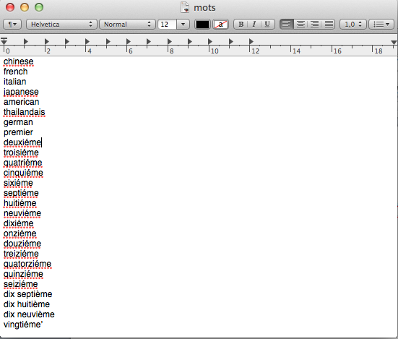

Let suppose we receive that mail :

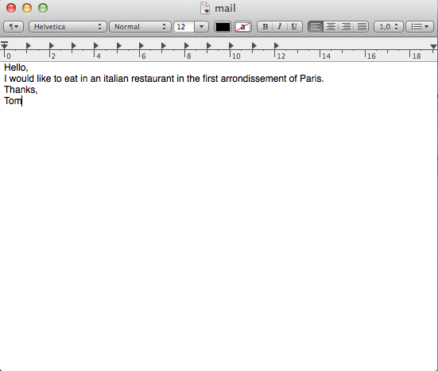

Now to get the key words from the email we need to compare the words of the file mots to the words from the file mail.

First we need to put replace spaces by carriage returns so every word will be on one line.

$ tr ' ' '\012' < mail_list

This will create the file mail_list.

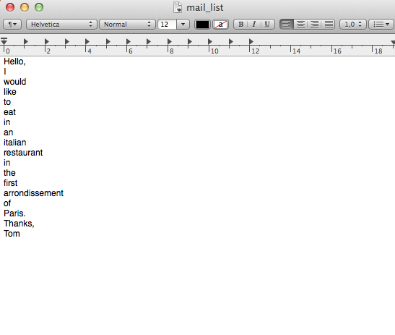

Then we need to delete all the punctuations in the mail so we don’t miss a key word.

$ cat mail_list | tr -d '[:punct:]’ > mail_list1

It creates the file mail_list1

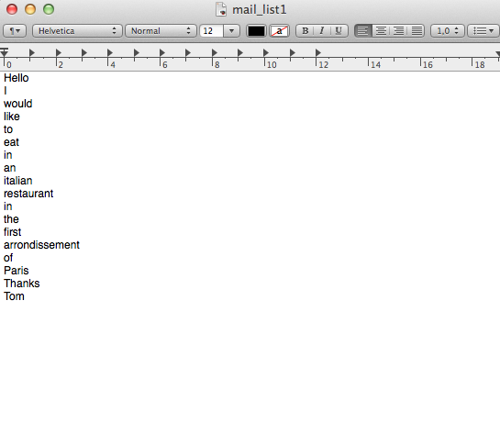

Now we can compare the two files mots and mail_list1.

$ comm -12 <(sort mots) <(sort mail_list1)

The terminal answers italian and first